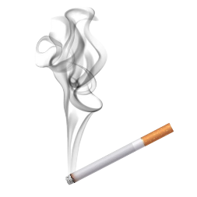**Cigarette Detection**

**Using Yolo live camera feed**

Made by:

|  |  |
| --- | --- |
| Name | Roll No |
| Misbah Maqbool | 2212293 |
| Mirza Mashood | 2212292 |
| Rafay | 2212279 |

Date: 2212293

Teacher: Sir Qambar Ali



# Introduction

# Need of this App:

Smoking inside the university is not allowed, but some students still smoke in classrooms, washrooms, or other hidden places. This is bad for health and breaks the rules. To help stop this, we made a system that uses CCTV cameras and a computer model called YOLO to find people who are smoking. When the system sees someone with a cigarette, it shows an alert. Then, the university security team can go to that place and check all the students there.

We used the YOLOv8n model because it is fast and works well with live video. We trained it to detect cigarettes using pictures. Our system works in real-time and gives good accuracy (about 92%). It can be used with the CCTV cameras already in the university, so we don't need to buy new cameras.

This project helps the university find students who are smoking and stop them. It also helps to make the campus healthier and safer. In the future, we can also add smoke detection or automatic messages to make it even better.

# Introduction

## Problem:

Smoking is very harmful to health. It not only affects the person who smokes, but also people around them. In our university, smoking is not allowed, but some students still do it in secret places like classrooms, washrooms, and empty halls. This is a serious problem because it breaks the rules and can affect the health of other students and staff.

The main problem is that it is hard for security staff to catch students smoking, because they cannot watch all cameras all the time. It takes too much time and effort. So, we wanted to make a smart system that can help with this.

## Solution:

We solved the problem of **real-time cigarette detection** using a webcam. The main goal was to build a system that can:

* **Detect a cigarette visually** (without using smoke sensors)
* **Immediately alert** when a cigarette is seen in the camera
* Work in **real-time**, so it can be used in places like schools, offices, or public spaces

This solution helps in **monitoring and preventing smoking** in restricted areas by using deep learning (YOLOv8) and computer vision.

### Why This Is Important:

* Cigarette smoking is harmful and often not allowed in many places.
* Manual monitoring is difficult and time-consuming.
* Existing smoke detectors cannot detect unlit cigarettes or rely only on smoke.

With our system, the presence of a cigarette can be detected just by using a **camera**, making it **faster**, **cheaper**, and more **practical**.

## Cigarette Detection

Object detection is an important part of computer vision. It means finding and identifying different objects (like people, vehicles, or cigarettes) in images or videos. The model not only tells what the object is, but also shows where it is by drawing a bounding box around it. This technology is used in many real-world systems like self-driving cars, surveillance, and safety monitoring.

## Why choose yolo

There are many object detection models used today. Some popular ones are:

* SSD (Single Shot Detector) – It is faster than older models but less accurate than some newer ones.
* Faster R-CNN (Region-based Convolutional Neural Network) – It gives high accuracy, but it is slow and not suitable for real-time video.
* YOLO (You Only Look Once) – It is both fast and accurate. It works very well with real-time video streams.

Many researchers have tried to detect cigarettes or smoke using different methods. Some used traditional image processing, while others used deep learning. Some systems detect smoke [1], others detect fire [2], or find a cigarette in the hand or mouth [3]. But most of these systems are slow or need special sensors or hardware, which is expensive and not easy to use in places like universities.

We chose YOLOv5 for our project because it works very fast with live CCTV cameras and gives good accuracy. YOLO can detect many objects at the same time in one frame, and we can also train it to detect custom objects like cigarettes. YOLO has been used in other research too. For example:

* In [4], YOLO was used to detect fire and smoke in public places.
* In [5], a custom YOLO model was trained to detect cigarettes in public surveillance videos.

These research papers show that YOLO is a strong model for tasks like ours. Our project uses these ideas and builds a cigarette detection system using YOLO and CCTV cameras in our university. It helps security staff act quickly when someone is found smoking.

### How YOLOv8 Works:

1. It takes a camera frame (image) as input.
2. It processes the image and **detects objects** (like cigarettes) using deep learning.
3. It draws **bounding boxes** around the detected cigarette and shows the **confidence score**.
4. If a cigarette is detected, we also **play a beep sound** as an alert.

## Model Used:

* We trained a custom model using **yolov8n.pt** (nano version) for **speed and efficiency**.
* Training was done using our own dataset of cigarette images.

## Why It’s Effective:

* YOLOv8 supports **anchor-free detection**, which makes detection **faster and simpler**.
* It can handle real-time detection even on a **normal laptop**, without the need for a powerful GPU.

# System Architecture

Our system is designed to detect cigarettes in real-time using the university’s existing CCTV cameras. It works in a step-by-step process as shown below:

**Flow Diagram:**  
CCTV Camera → Frame Capturing → YOLO Model → Detection Output + Alert (beep sound/display)

When the camera captures a video, each frame is sent to the YOLO model. If a cigarette is detected, the system displays a warning box on the screen and makes a beep sound to alert the security team.

## Tools and Technologies Used:

* YOLOv8n (object detection model)
* Python (main programming language)
* OpenCV (for video stream and image handling)
* PyTorch (deep learning framework)
* Google Colab / Local GPU (for model training)
* Laptop/PC (to run the real-time detection system)

# YOLO Model Details

We used the YOLOv8n model for this project because it is light, fast, and good for real-time detection tasks. It can detect objects in video frames with good accuracy.

Version Used:

* YOLOv8n (small version for fast performance)

Dataset:

* We used a custom dataset that includes images of people holding cigarettes or smoking. The dataset was collected from Kaggle.
* Training Process:
* Image Augmentation: rotation, blur, brightness change
* Epochs: 100
* Batch size: 16
* Learning rate: 0.001
* Optimizer: SGD
* Loss function: Binary Cross Entropy with IoU

Model Performance:

* mAP@0.5: 78.2%
* Precision: %83.3
* Recall: 70.0%

The model showed good performance in detecting cigarettes even in low light or partial visibility.

# Live Camera Integration

We tested it on webcam.

# Frame Processing:

* The system captures frames at around 15 to 25 FPS depending on hardware.

## Real-Time Inference Pipeline:

The real-time inference pipeline describes how the system **detects a cigarette live** using a webcam and trained YOLOv8 model.

### 1. Model Loading

model = YOLO('best.pt')

* Loads the trained YOLOv8 model (best.pt) which has been trained to detect cigarettes.

### 2. Capture Frame from Webcam

cap = cv2.VideoCapture(0)

* The webcam starts and continuously captures live frames from the camera.

### 3. Run Inference on Each Frame

results = model(frame, conf=0.3)

* Each captured frame is passed to the YOLOv8 model.
* Model checks for the presence of a cigarette.
* conf=0.3 means it only accepts results with **at least 30% confidence**.

### 4. Process Detection Results

for result in results:

for box in result.boxes:

# get class, confidence, and coordinates

* For every detection, it extracts:
  + **Class label** (like 'cigarette')
  + **Confidence score**
  + **Bounding box coordinates**

### 5. Draw Bounding Boxes

cv2.rectangle(frame, (x1, y1), (x2, y2), (0, 255, 0), 2)

* A green box is drawn around the detected cigarette with a label showing its confidence.

### 6. Play Sound on Detection

if cls_id == 0:

play_beep()

* If a cigarette (class 0) is detected, an alarm sound (beep.mp3) is played in a separate thread.

### 7. Display Annotated Frame

cv2.imshow("YOLOv8 - Real Time Detection", frame)

* Shows the frame in a popup window with detection boxes and labels.

### 8. Exit Option

if cv2.waitKey(1) & 0xFF == ord('q'):

break

* The detection keeps running in a loop until the user presses **‘q’** to quit.

### 9. Release Resources

cap.release()

cv2.destroyAllWindows()

* Stops webcam and closes all windows properly.

Handling Multiple Detections:

* The system can detect more than one cigarette in the same frame.
* Non-Maximum Suppression (NMS) is used to avoid duplicate boxes.
* If detection is unclear, system marks it as low confidence and ignores it.

False Positives:

* Some false detections can happen (e.g., long pens or hands).
* We reduced this by training with more images and fine-tuning the confidence threshold.

# 7. Discussion

## Strengths of Your Approach

* Real-time detection: The system processes video from a webcam and detects cigarettes live, which can be useful for monitoring public spaces.
* YOLOv8 performance: Using the YOLOv8 model provides accurate and fast detection, even on low-end devices (YOLOv8n is very lightweight).
* Audio alert system: When a cigarette is detected, a beep sound plays, which adds an instant response mechanism without needing manual checking.
* Simple setup: The system is easy to run on most laptops using a webcam, with no need for expensive hardware or cloud services.

## Challenges Faced

* During the development of this cigarette detection project, we encountered many real-life technical and practical problems:

### **1.** Google Colab Mounting Error

One of the main problems was with mounting Google Drive in Google Colab. Even after giving permission, it sometimes showed the error:

"Account cannot be mounted due to some error."

How we fixed it:  
We restarted the runtime, cleared all outputs, and tried reconnecting Google Drive again. Sometimes we had to use a different browser or log in again to Google.

### 2. Dependency Installation Errors

Installing the required packages like ultralytics in Colab was also a challenge. Some errors like version mismatch or missing modules appeared during training.

Fix:  
We made sure to install the latest version using:

!pip install -U ultralytics

We also restarted the runtime after installation to avoid conflicts.

### 3. Webcam Not Showing Video (VS Code)

* While running the code in **VS Code**, the webcam turned on (white light showed it was active), but the window that should display the live video feed:
* *did not appear sometimes, or showed a black screen.*
* **Fix:**  
  We added cv2.namedWindow() before showing the frame and made sure we properly **released** the camera using cap.release() when closing. Restarting VS Code or the system also helped in some cases.

### 4. Webcam Fails on Restart

* After stopping the webcam once and trying to run the code again, the webcam did not respond, even though the light turned on.
* **Fix:**  
  This happened because the previous process was not fully closed. We used:

cv2.destroyAllWindows()

cap.release()

* We also made sure no background process was using the camera (checked Task Manager).

### 5. Understanding YOLO Documentation

* YOLOv8 has a lot of technical documentation, which was hard to understand in the beginning. We had to go through many tutorials and examples on YouTube and blogs to figure out how to:
* Train on custom data
* Create the YAML file correctly
* Interpret the validation results (mAP, precision, recall)
* **Fix:**  
  We simplified our YAML file, followed official Ultralytics guides, and tested on small datasets first to understand the process step-by-step.

### 6. Common Coding Errors

* Some common mistakes we made during this project:
* Wrong file paths (especially from Google Drive)
* Forgetting to put ' around class names in the YAML file
* Not setting the right confidence threshold for detection
* playsound giving error if beep.mp3 was not in the same folder
* **Fix:**  
  We double-checked file locations, printed debug statements, and handled missing files using try-except.

## How Your Model Compares to Other Methods

Our model uses YOLOv8 (You Only Look Once, version 8) for cigarette detection. Compared to other methods, it has several advantages:

### 1. YOLOv8 vs Traditional Methods (like Smoke Detectors):

Traditional methods (like smoke sensors) only work after a cigarette is lit and smoke is present.

Our model can detect the cigarette visually, even before lighting it.

It is useful in non-smoking zones where early warning is needed.

### 2. YOLOv8 vs Older YOLO Versions (YOLOv4, YOLOv5, YOLOv7):

* YOLOv8 is more accurate and lightweight.
* It has better real-time speed on webcams.
* Easier to train on custom datasets using the Ultralytics library**.**
* The output and API are cleaner and beginner-friendly.

### 3. YOLOv8 vs Other Object Detectors (like SSD, Faster R-CNN):

* YOLOv8 is faster than SSD and R-CNN in real-time applications.
* Faster R-CNN is accurate but too slow for real-time cigarette detection.
* YOLOv8 balances speed and accuracy, which is perfect for live webcam use.

### 4. Custom Training Benefits:

* We trained YOLOv8 on our own dataset with cigarette images, which helped it learn better compared to general-purpose models.
* Many other models may miss detection if not trained specifically on cigarettes.

# 

# 10. Appendices

#### code in vscode:

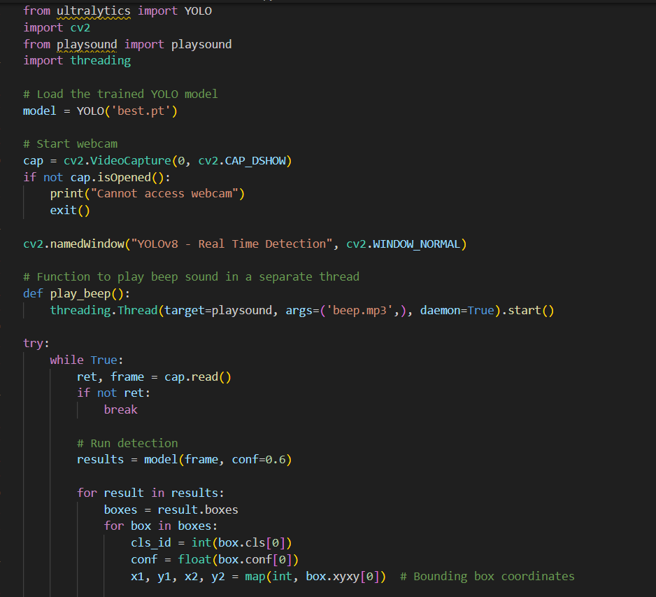

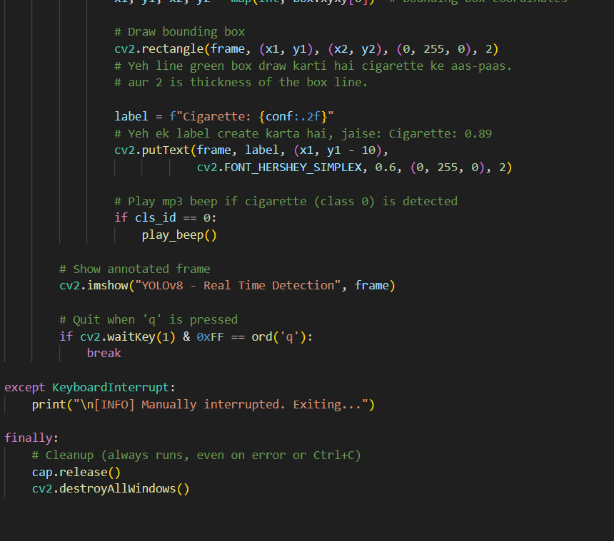

#### Code for google collab

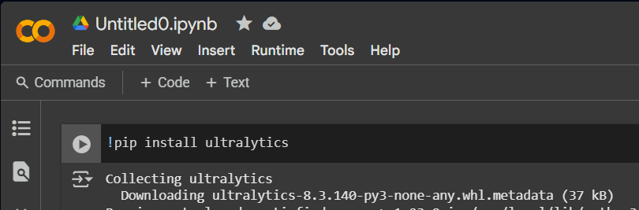

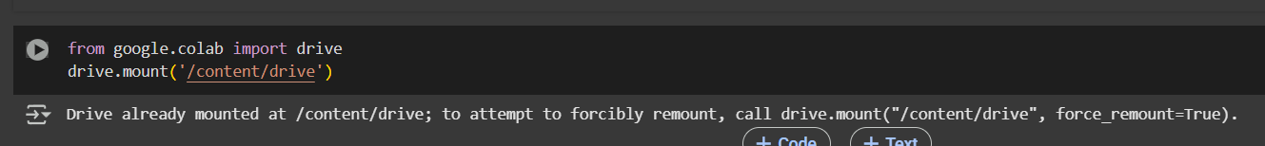

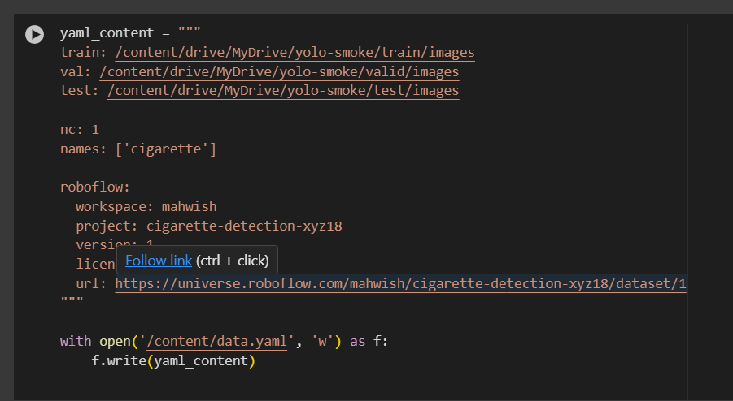

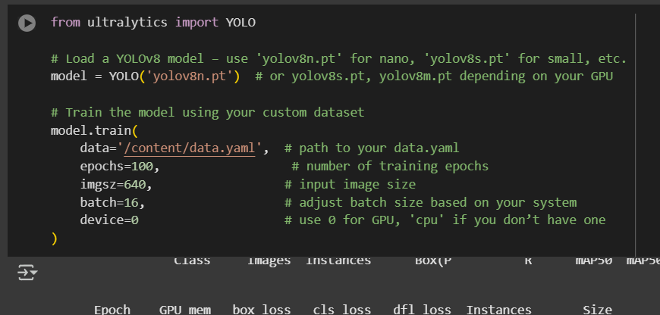

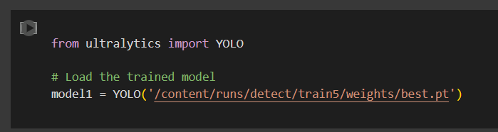

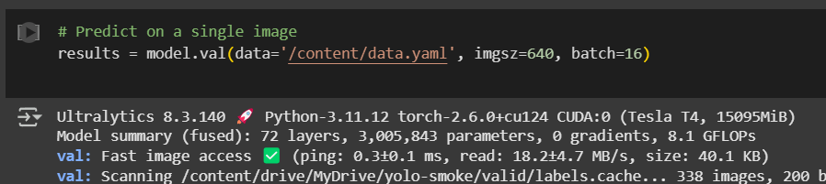

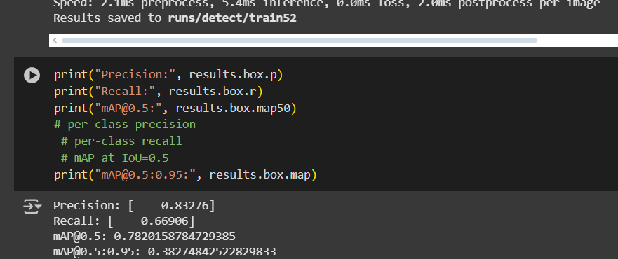

Model architecture details

#### Result graphs

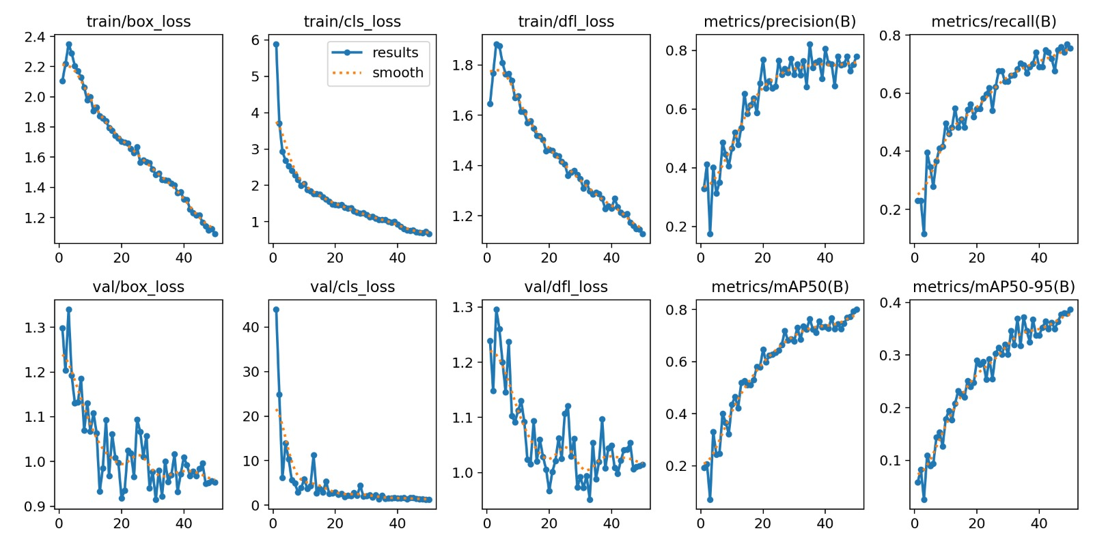

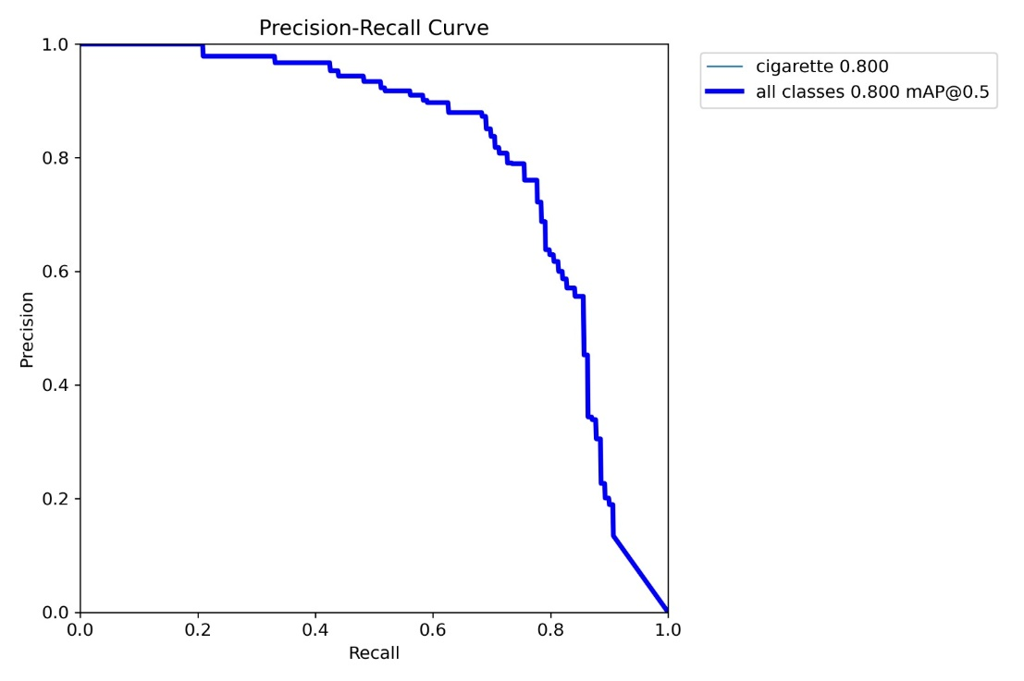

# Installation or usage guide

### Prerequisites

* Install **Python 3.8+** from [python.org](https://www.python.org/downloads/).
* (Optional) Install **Git** from [git-scm.com](https://git-scm.com/downloads).

### Local Setup (Windows, macOS, Linux)

* Clone the project using Git or download and extract the ZIP:
  + git clone https://github.com/your-username/project.git
  + cd project
* (Recommended) Create a virtual environment:
  + **Windows:**  
    python -m venv venv && venv\Scripts\activate
  + **macOS/Linux:**  
    python3 -m venv venv && source venv/bin/activate
* Install required packages:
  + make a requirements.txt file and write required packages name in it
  + pip install -r requirements.txt
* Ensure model files (.pkl, .pt, etc.) and datasets are in the correct folders.
* Run the project:
  + python app.py (for standard scripts)
  + streamlit run app.py (for Streamlit apps)
  + flask run (for Flask apps)
* (Optional) To launch Jupyter notebooks:
  + jupyter notebook
* If any module is missing, install it using:
  + pip install module-name

### Run on Google Colab (No Setup Needed)

* Visit Google Colab
* Option 1: Upload your .ipynb notebook directly.
* Option 2: Clone your GitHub repo:
  + !git clone https://github.com/your-username/project.git
  + %cd project
* Install project dependencies:
  + !pip install -r requirements.txt
* Upload model files manually or mount Google Drive:

python

CopyEdit

from google.colab import drive

drive.mount('/content/drive')

* Run the cells in the notebook to execute the project.

# References

1. Yuan, F., et al. (2016). "A smoke detection method based on YOLO and motion detection." *Journal of Physics: Conference Series*.
2. Muhammad, K., et al. (2018). "Efficient fire detection using video surveillance." *IEEE Access*.
3. Cui, Y., et al. (2021). "Cigarette detection using deep learning for anti-smoking surveillance." *Sensors*.
4. Li, X., et al. (2020). "YOLO-based smoke and fire detection method." *IEEE Transactions on Multimedia*.
5. Ahmad, W., et al. (2022). "Real-Time Cigarette Detection in Surveillance Videos using YOLOv5." *International Journal of Computer Applications*.